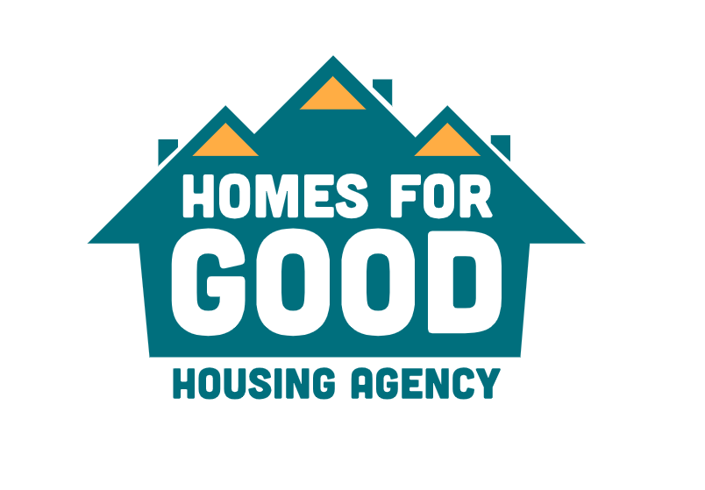

REQUEST FOR PROPOSAL
25-M-0013
Proposals Due:
Monday, February 10, 2025, at 2:00 PM

Contract Administrator
Marc Hashagen
PH: (541)-682-2587- Cell (541)-852-6043
Email: mhashagen@homesforgood.org

Email: jleary@homesforgood.org

TABLE OF CONTENTS

Basic Overview 3
Homes for Good Overview 4
Scope of Work 5-6
Submission Requirements 6-7
Expectations & Requirements 7-8
Evaluation & Selection Criteria 9

BASIC OVERVIEW

RFQ Release Date | January 10, 2025
Submission Due Date & Time | February 10, 2025, by 2 PM
Submission Methods | Email to mhashagen@homesforgood.org
Pre-Proposal On-site Visit | Thursday, January 23, 2025, 9:30 AM at 2135 W. 12th Avenue, Eugene, OR 97402
Anticipated Contract Term | March 3, 2025- March 28, 2025 (26 calendar days)
Maximum Number of Contracts Awarded | 1
Agency Contact | Marc Hashagen  mhashagen@homesforgood.org  (541)-682-2587- Cell (541-852-6043
Subcontracting | Permitted
Questions Regarding the RFP | Monday, January 27, 2025, by 2 PM

HOMES FOR GOOD OVERVIEW
WHO WE ARE…
Homes for Good is Lane County’s housing agency and our primary work is to help low-income residents with the logistics of affordable housing. At a higher level, we are neighbors united to get every Lane County resident who needs help into a home.

WHAT WE DO…
- Rental Assistance Vouchers
- Help veterans, seniors, and people with disabilities find and secure affordable housing
- Match low-income residents with public and assisted housing units
- Partner with other community organizations and non-profits to build, finance and develop affordable housing
- Connect residents with self-sufficiency programs and wellness supports
- Work with the low-income community to provide help with weatherization improvements that lower utility bills and keep homes more comfortable
- Raise awareness about the need for low-income and affordable housing in Lane County

AFFORDABLE HOUSING ADVOCATES…
We work to raise awareness about the need for – and lack of – affordable housing here in Lane County and more broadly. There is no question that the need for affordable housing will only grow as our population increases and high demand for housing pushes rents and prices up. We believe every person should have a home and that we must proactively and aggressively work toward that goal for the good of our community, state and nation.
DIVERSITY EQUITY AND INCLUSION
Our goal is to address racial disparities within our organization in our hiring and promotion practices, greater opportunities in contracting and equitable services available to the people we serve. We want to establish Equity as part of our DNA as an organization
SCOPE OF WORK

The Project Site is located at:
2115, 2123, and 2135 W. 12th Ave. Eugene, OR 97402
The work includes, but is not limited to:

- Installation of Ductless heat pumps and bath fans in twenty-eight (28) units consisting of one and two-bedroom apartments in two-story complexes. Some units will also include the installation of kitchen range hoods and ducting for exterior walls.

- Ductless heat pumps are to be sized as per Manual J and to be installed following the Standard Work Specifications for Ductless Heat Pump Installation. Sizing report to be submitted to Homes for Good with proposal. Manual J calculations can be calculated at current building shell R-values as the buildings are fully insulated to code. Ductless heat pumps are to be controlled with wall-mounted thermostats. Exterior units are to be placed on gravel pads surrounded with pressure-treated lumber. Units to be Energy Star Certified. Installation of GFCI outlets for DHP’s as per building code. Contractor shall provide proof of approved final inspection by City of Eugene prior to payment.

- Bath fans are to be Panasonic Whispergreen fans and controlled with AirCycler Smart Switch. GFCI circuit breaker to be installed on bath fan circuits due to fans being in proximity of shower stalls. Downstairs units have fans already ducted to wall and will only require new terminations. Terminations to have 1/4” mesh. Some upstairs units will need additional ducting as some ducting currently terminates in attic space. Only existing roof jacks may be used. Collars will need to be installed/fabricated to ensure proper seal to the existing roof jacks.

- Kitchen range hoods to be standard 30” with a short run of ducting to exterior wall with termination. Soffits to contain ducting to be installed by Homes for Good staff.

- The installation in these units will be coordinated between the Contractor and Homes for Good Staff.

- General Conditions and Specifications of work apply to all work done on this contract.
- All Qualified contractors, all Minority Business Enterprises, and Section 3 businesses are encouraged to participate in this solicitation.
- All questions should be directed to the Contract Coordinator

Proposals shall be sent in the format requested, by Monday, February 10, 2025, and can be sent by email to the solicitation coordinator at mhashagen@homesforgood.org

SUBMISSION REQUIREMENTS

Your response to the Request for Proposal must contain all the information requested along with acknowledgment of all attachments (if applicable). A completeness check will be conducted for each submission. Incomplete submissions will not be accepted. Submissions should include the items organized and numbered to correspond to each requirement below:
General
Proposals will be clear and concise. Homes for Good encourages green options and requests that responses to this RFP be emailed to the Contract Administrator. If file size exceeds email limits, please provide a thumb drive containing your proposal.
Cover Letter
All proposals must be accompanied by a cover letter signed by an individual who is legally authorized to enter into a contract on behalf of the proposing individual/firm. The letter must designate the Proposer’s contact person during the proposals review process. Also, include a statement that the submission is a firm offer for a 90-day period.
Additional Services
If it should become necessary for Homes for Good to request the organization to render additional services to either supplement the services requested in the RFP or to perform additional work, then such additional work shall be performed only if set forth in an addendum to an engagement letter between Homes for Good and the organization. Any such additional work agreed to between Homes for Good and the firm shall be performed at the same rates set forth in the fee proposal. Submit an hourly fee estimate for additional services.
Qualifications
Include a detailed statement of qualifications for the organization. This should include organizational history, clients presently served, and capacity to complete the scope of work.
Fee Proposal
Provide per-unit pricing for equipment to be installed
Diversity Equity & Inclusion (DEI)
The proposal should include the firm’s DEI strategies. This section will be evaluated on the firms commitment to engaging diverse populations, particularly those facing disparities. The maximum score will be given to firms that have formally adopted Diversity, Equity, and Inclusion strategies and MWESB strategies. The following information should include:
- Describe your organization’s DEI strategies to removing barriers and creating opportunities for populations facing disparities in order to maximize workforce diversity.
- Your organization’s plan for maximizing Minority and Women Owned, and Emerging Small Businesses (MWESB) participation and/or Section 3 participation.
- Homes for Good is striving for a 20% MWESB contractor/vendor utilization rate on the proposed project. Please describe your organization’s MWESB and/or Section 3 utilization rate on recent projects.

EXPECTATIONS & REQUIREMENTS

Additional Work
During the awarded contract period, Homes for Good may request additional work and the Contractor will be asked to provide a cost for that work. This Agency may or may not authorize such additional work to the awarded contractor and reserves the right to use another Contractor.

Insurance Coverage Requirements
At signing of contract, the awarded Contractor is required to provide the Agency with Certificates of Insurance showing the following Insurance is in force and will insure all operations under this contract. Contractors shall not cancel, materially change, or not renew insurance coverages during the period of this contract. Any insurance bearing any adequacy of performance shall be maintained after completion of the contract for the full warrant/guarantee period.
Nothing contained in the insurance requirements is to be construed as limiting the extent of the Contractor’s responsibility for payment of damages resulting from the Contractor’s operation under a contract with Homes for Good.

General Contractor’s General Liability

- Workers’ Compensation: In accordance with State Law, the general Contractor, its subcontractor, and all employers working under the contract are subject employers under the Oregon Workers' Compensation Law and shall comply with ORS 656.017, or otherwise be exempt under ORS 656.126.
- Automobile Liability: For owned and non-owned motor vehicles used on the site or in connections therewith for a combined single limit for bodily injury and property damage of not less than $500,000 per occurrence.
- Commercial General Liability & Professional Liability: The minimum limit of liability shall be $1,000,000 per occurrence written, with a combined single limit for bodily injury and property damage.

The General Contractor’s General Liability policy shall name the Agency as Additional Insured for this project, with an attached Endorsement Page, showing the additional insured as:

Homes for Good Housing Agency
100 West 13th Avenue
Eugene, OR 97401

Payment
Agency will review Contractor’s invoice and within ten (10) days of receipt notify Contractor in writing if there is a disagreement or dispute. If there are no such disputes, Agency shall pay the invoice amount in full within (30) days of invoice send date.
Prospective proposers may contact Marc Hashagen by email at mhashagen@homesforgood.org for further information regarding this process or to request clarification. Follow-up questions and/or clarifications may continue to be submitted in this fashion until January 27, 2025, by 2 PM.
EVALUATION & SELECTION CRITERIA

A committee comprised of representatives from Homes for Good will review the proposals for conformity with the requirements of the Request for Proposals described above. Conforming proposals will be evaluated according to the evaluation criteria.
First, the proposals will be examined to determine whether the organization satisfies the mandatory elements identified below. Next, the committee will use the selection criteria to score each proposal.

Evaluation Criteria
Proposals will be evaluated using two sets of criteria. Firms meeting the mandatory criteria will have their proposals evaluated and scored. The following represents the criteria that will be considered during the evaluation process.

OBJECTIVE CRITERIA | POSSIBLE POINTS
Cost | 60
DEI Strategies | 10
Completeness of RFP | 15
SUBJECTIVE CRITERIA | POSSIBLE POINTS
The qualifications of the organization | 15
TOTAL | 100

